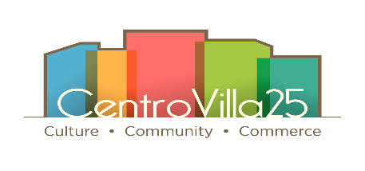
Northeast Ohio Hispanic Center For Economic Development
CentroVilla25 Capital Campaign
Pledge Form

Please accept my Gift of $ __________ to be paid as follows:
- One-time lump sum contribution of $
- Contribution Over Time: Total Pledge Amount = $ _________________________
An initial contribution of $___________________ and,
Subsequent contributions of $ will be made: __Yearly __Semi-annually __Quarterly __Monthly
Paid over: __ One year __Two years __Three years; Starting on (Month/Year) __________ / __________.

FORM OF PAYMENT
- Lump Sum or Initial Contribution
___ Check - Make payable to the HISPANIC BUSINESS CENTER-CV25
___ Credit Card - Please enter information below OR choose to contribute securely online at:
https://www.hbcenter.org/donations/campaigncv25/
- Subsequent/Recurring contributions will be paid by: ___Check ___Credit Card
Please set-up payments through the secure online portal

Will you require payment reminder/invoice? __ Yes __ No

First Name: _______________________________________ Last Name: ______________________________________
Address: ________________________________________________ City _____________________________________
Zip Code ________________ Telephone: ______________________ Mobile/Cell: ______________________________
Email:
Pledge Signature*: _____________________________________________________ Date: _______________________
Name(s) to list in donor acknowledgement: ______________________________________________________________
____ Check here if you wish this gift to remain anonymous.
Additional Terms/Instruction: __________________________________________________________________________

I am (We are) eligible for employer matching funds from (Company), and
I (We) wish to secure gift credit for matching contributions from that source: Yes N o

If not using online portal provide the following information:
Credit Card: ___American Express ___Discover ___ MasterCard ___VISA

Name on Card (please print):

Credit Card # Exp. Date: / CVV

Billing Address (IF different than above address): _______________________________________________________

City: State Zip Code

Card Authorizing Signature: Date:

For more information please contact: jcontreras@hbcenter.org and/or Call (216) 281-4422 (Office & Fax)
*Please return the completed form via email, fax or by mail to:
Jenice Contreras, Executive Director, NEOHCED, 2511 Clark Avenue, Cleveland, OH 44109

Thank You For Your Contribution!
NEOHCED is a 501(c)3 nonprofit EIN #34-1805510. Your gift may qualify as a charitable contribution. Consult with your tax adviser.

